# Brainstorm

**TIP**

You can select a sticky note and hit the pencil [switch to sketch] icon to start drawing!

**& idea prioritization**

Use this template in your own brainstorming sessions so your team can unleash their imagination and start shaping concepts even if you're not sitting in the same room.

**10 minutes** to prepare

**1 hour** to collaborate

**2-8 people** recommended

## Before you collaborate

#### A little bit of preparation goes a long way with this session. Here’s what you need to do to get going.

**10 minutes**

##### Team gathering

Define who should participate in the session and send an invite. Share relevant information or pre-work ahead.

##### Set the goal

Think about the problem you'll be focusing on solving in the brainstorming session.

##### Learn how to use the facilitation tools

Use the Facilitation Superpowers to run a happy and productive session.

##### [Open article](https://support.mural.co/en/articles/2113740-facilitation-superpowers)

**1**

## Define your problem statement

#### What problem are you trying to solve? Frame your problem as a How Might We statement. This will be the focus of your brainstorm.

**5 minutes**

**Heavy and irregular rainfall can have many irregular impacts on crops and farming lands.Leading to poor growth and overall health of crop.**

**Key rules of brainstorming**

To run an smooth and productive session

**2**

## Brainstorm

#### Write down any ideas that come to mind that address your problem statement.

**10 minutes**

**T.Yasaswini**

identify the problem

predicting the amount of rainfall in advance

Poor environmental conditions

water can be stored efficiently through dams and reservoirs

**T.Somalinga**

**V.SalmanSiddhu**

adaptation of new techno;ogies

following new cropping patterns

cultivate seasonal based crops

monsoon forecasting is being monitored

**U.PraveenReddy**

**3**

## Group ideas

#### Take turns sharing your ideas while clustering similar or related notes as you go. Once all sticky notes have been grouped, give each cluster a sentence-like label. If a cluster is bigger than six sticky notes, try and see if you and break it up into smaller sub-groups.

**20 minutes**

Predicting the amount of rainfall in advance

Monsoon forecasting is being monitored

**4**

## Prioritize

#### Your team should all be on the same page about what's important moving forward. Place your ideas on this grid to determine which ideas are important and which are feasible.

**20 minutes**

Machine learning algorithm is used for prediction

Developing Data Science platform to predict the rainfall anlaysis

Machine learning algorithm is used for prediction

Developing Data Science platform to predict the rainfall anlaysis

usage of natural fertilizers

temparature changes are analysed

Machine learning algorithm is used for prediction

Developing Data Science platform to predict the rainfall anlaysis

trying to find new sources

cultivate the crops based on water needs

**TIP**

Add customizable tags to sticky notes to make it easier to find, browse, organize, and categorize important ideas as themes within your mural.

## After you collaborate

#### You can export the mural as an image or pdf to share with members of your company who might find it helpful.

**Quick add-ons**

##### Share the mural

**Share a view link** to the mural with stakeholders to keep them in the loop about the outcomes of the session.

##### Export the mural

Export a copy of the mural as a PNG or PDF to attach to emails, include in slides, or save in your drive.

**Keep moving forward**

##### Strategy blueprint

Define the components of a new idea or strategy.

##### [Open the template](https://app.mural.co/template/e95f612a-f72a-4772-bc48-545aaa04e0c9/984865a6-0a96-4472-a48d-47639307b3ca)

**Customer experience journey map**

Understand customer needs, motivations, and

Stay in topic.

Defer judgment.

consulting meterologists about weather conditions

adopt rainwater harvesting techniques

advanced planning in storage of gains

developing data science platform to predict the rainfall analysis

set up a rain cover

rain gauge is used to measures the amount of rain

Encourage wild ideas.

Listen to others.

### Importance

machine learning algorithm is used for predicting rainfall

altered climate changes

If each of these

Machine learning algorithm is used for prediction

Developing Data science platform to predict the rainfall analysis

done without any

Predicting the amount

find new ideas to predict crops

make a rain saucer

detect the direction of wind

analysis rainfall using new techno;ogies like rainfall

advance

obstacles for an experience.

##### [Open the template](https://app.mural.co/template/b7114010-3a67-4d63-a51d-6f2cedc9633f/c1b465ab-57af-4624-8faf-ebb312edc0eb)

Go for volume. If possible, be visual.

tasks could get

difficulty or cost, which would have the most positive impact?

of rainfall in

##### Strengths, weaknesses, opportunities & threats

Identify strengths, weaknesses, opportunities, and threats (SWOT) to develop a plan.

|  |  |
| --- | --- |
|  |  |
|  |  |

##### [Open the template](https://app.mural.co/template/6a062671-89ee-4b76-9409-2603d8b098be/ca270343-1d54-4952-9d8c-fbc303ffd0f2)

heir ere o on

r can sing ng the

d.

**TIP**

Participants can use t cursors to point at wh sticky notes should g the grid. The facilitato confirm the spot by u the laser pointer holdi **H key** on the keyboar

##### [Share template feedback](https://muralco.typeform.com/to/CiqaHVat?typeform-source=app.mural.co)

Predicting the amount of rainfall in advance

monsoon forecasting is being monitored

[**Share template feedback**](https://muralco.typeform.com/to/CiqaHVat?typeform-source=app.mural.co)

**Feasibility**

Regardless of their importance, which tasks are more feasible than others? (Cost, time, effort, complexity, etc.)

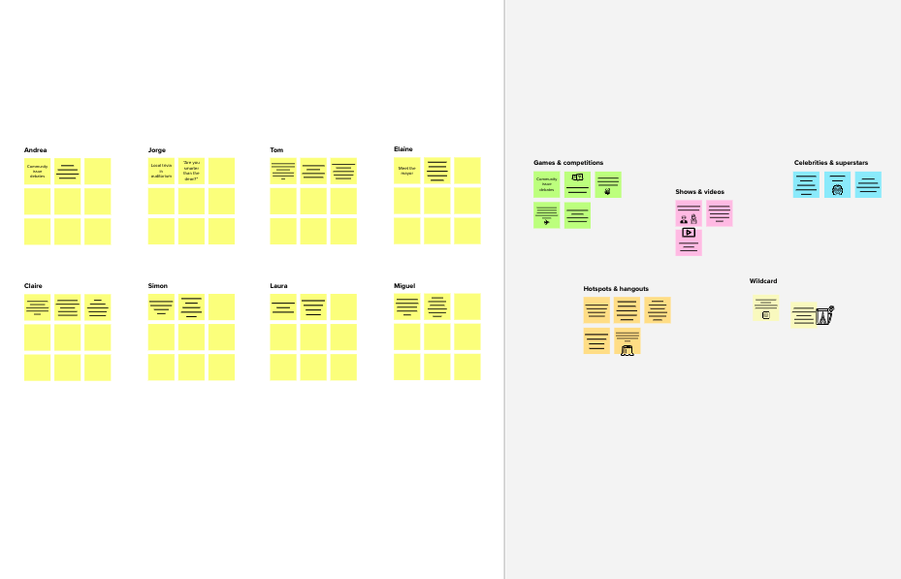

**Template**

**Need some inspiration?**

See a finished version of this template to kickstart your work.

[**Open example**](https://app.mural.co/template/e5a93b7b-49f2-48c9-afd7-a635d860eba6/93f1b98d-b2d2-4695-8e85-7e9c0d2fd9b9)